Select ename,sal,sal\*0.05 AS “5% increment”

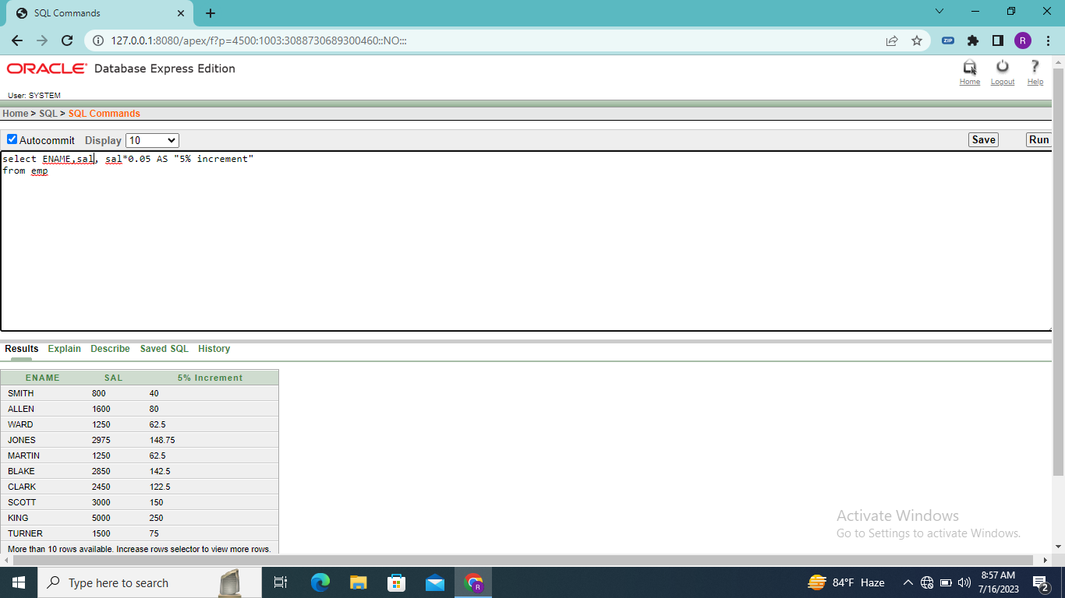select \* from salgrade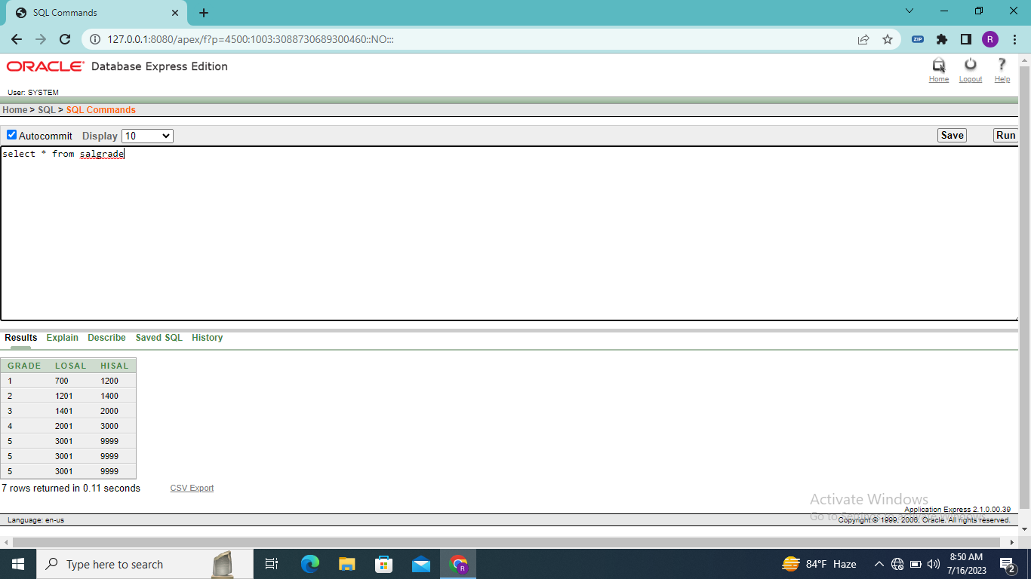

Select deptno from dept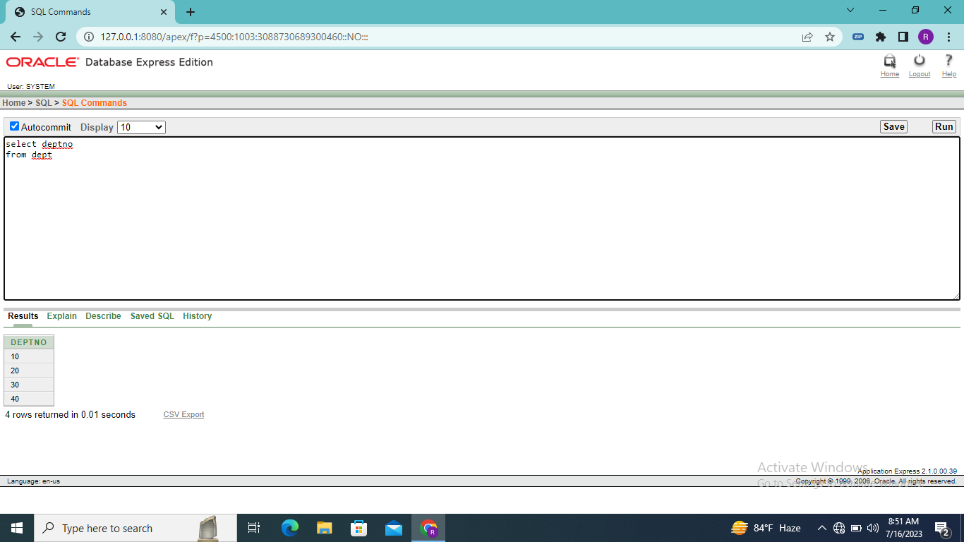

Select DISTINCT JOB from emp

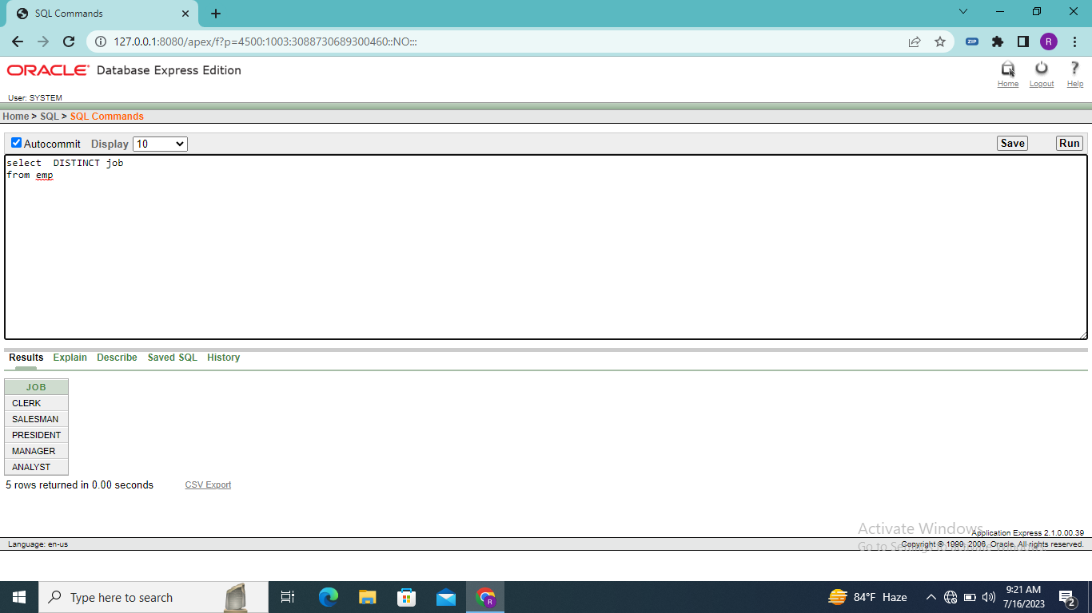select ename,sal,sal\*0.05 AS “5% increment” ,sal\*0.05+sal as “NEW SALARY” from emp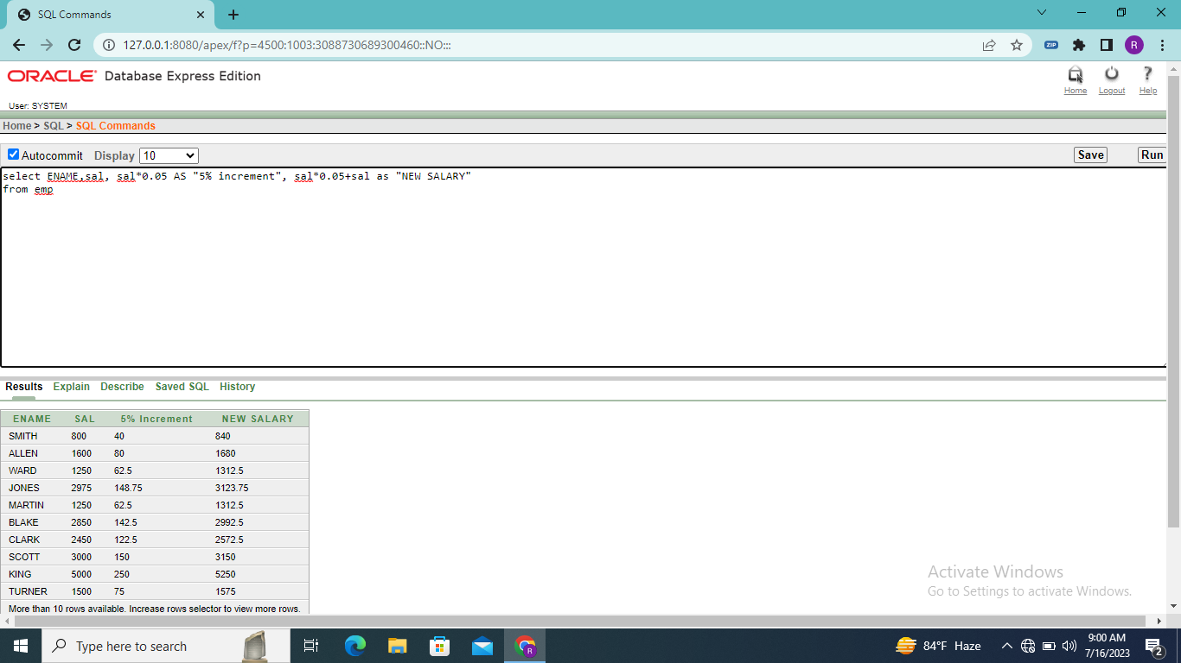

Select ename,deptno,sal from emp where ename=’BLAKE’

